Name:
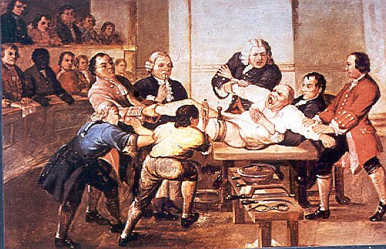
Medicine in Britain, c1250-present

This booklet is designed to support you in your studies – reading around the subject at home will be essential.
This exam paper will ask you questions on both Medicine Through Time and Medicine on the Western Front (see additional support guide).
You will need to answer 3 questions and have 50 minutes to do this.
You must answer Questions 3 and 4 and then choose either question 5 or question 6.
This is worth 20% of your final GCSE grade.

This revision guide is designed to help support you in preparing you for your medicine through time exam. You will have 50 minutes to answer three questions; but as this is a study over time you will need to be able to see the patterns of continuity and change over time. There are five units to study here:
How to work out centuries:
Cover the last two numbers and add one to the remainder.
E.g. 1914 is in the twentieth century
1252 is in the thirteenth century

Advice – there are a lot of events here over a long period of time – don’t get bogged down in learning the dates for every single event, instead focus on the time period that this event occurs and what happened before and afterwards.
c.1700 wherever you see a small ‘c.’ before a date this means ‘circa’ or around. Usually used when we are not talking about exact dates.
- Medieval Medicine
- Renaissance Medicine
- Medicine in 18th and 19th century Britain
- Medicine from 1900 to the present day.
- Medical Treatment during the First World War

Each unit contains key words for that unit as well as practice questions on the things that you have just studied. Have a go at these as part of your revision and give them to your teacher to mark.
You will be expected to answer six questions in total – the first three will be on medicine on the Western Front and then three on Medicine Through Time. You will need to answer questions 3 and 4, and then choose either 5 or 6.

Question 3: Explain one way…. 4 marks
This is only worth four marks so aim to spend only five minutes on this. You are expected to give either a similarity or a difference and only one comparison is needed. You should compare by referring to both periods in the question. Students often fall into the trap or writing too much here so keep it to the point and move on.

Question 4: Explain why… 12 marks
This asks you to explain the reasons why something has happened. You should spend about 15 minutes on this question. You are given two information points as prompts but you do not have to use them. Higher marks are gained by adding in a point extra to the prompts. Aim to write an answer that gives at least three reasons.

EITHER Q5 or Q6 How far do you agree… [16 marks + 4 SPAG]
Spend about 30 minutes on this question and to check you spelling, punctuation and grammar – particularly capital letters! You will have prompts to help you and a choice of which question you want to answer. The statement given might be about how significant, causes of change, continuity over time, similarities, differences. Identify what type of question it is before you start.
You must make a judgement and you should think about both sides of the argument. Spend some time planning this answer before you start – put your points under ‘for’ and ‘against’ headings. You should consider at least three points and be clear on why you think one reason is more important than another.
When completing an extended answer use these connectives to develop your answer into an explanation.
Be very careful not to tell the story when explaining something – if you are using these connectives then you will be explaining instead of describing

To compare
equally likewise similarly as with like in the same way

To contrast
whereas instead of alternatively otherwise unlike but on the other hand

To show cause and effect
because so therefore thus consequently this led to…

To further explain an idea
although however unless except apart from yet if as long as

To emphasise
above all in particular especially significantly indeed notably

To give examples
for example such as for instance in the case of as revealed by
Unit 1: Medicine in Medieval England c1250-1500
Theories about the cause of disease
Key words
Malnutrition an illness caused by lack of food
Leprosy skin disease, followed by paralysis and death
Diagnosing looking at symptoms to decide what is wrong with a patient
Physician another name for a doctor
Vivisection criminals who were dissected alive
Scourge something that causes great suffering
Flagellants a group who punished themselves during the Black Death in the hope that God would take pity
Quarantine Separating the sick from the healthy
Astrology
The alignment of the planets and stars was important in diagnosing illness. Star charts would be used by physicians. This was a supernatural explanation for disease.
Religion
People in medieval England were very religious and followed the Catholic religion. Illness was very common (malnutrition was very common) and remained a mystery so the Church used religion to provide the answers. They taught that sins would be punished by God and that the God or the devil could send disease. The church also declared that a miracle had happened when they recovered, thanks to prayer. Leprosy was a disease believed to have been sent by God.

The Four Humours Theory
This was an idea from Ancient Greek times. It stated that, as the world was made up of four different elements, the body was made up of four different humours:
- Blood
- Phlegm
- Black bile (clotted blood – could be in excrement or vomit)
- Yellow bile (pus or vomit)
The theory was created by Ancient Greek physician Hippocrates – he observed patients carefully and recorded his findings. The idea of the humours fitted what he saw. In Ancient Rome, Galen, another famous doctor, developed the theory further. He created the Theory of Opposites, for example he said that an excess of phlegm could be cured by eating hot peppers, a fever could be cured by cucumbers to cool the patient down. He also said that blood was created in the liver and circulated around the body

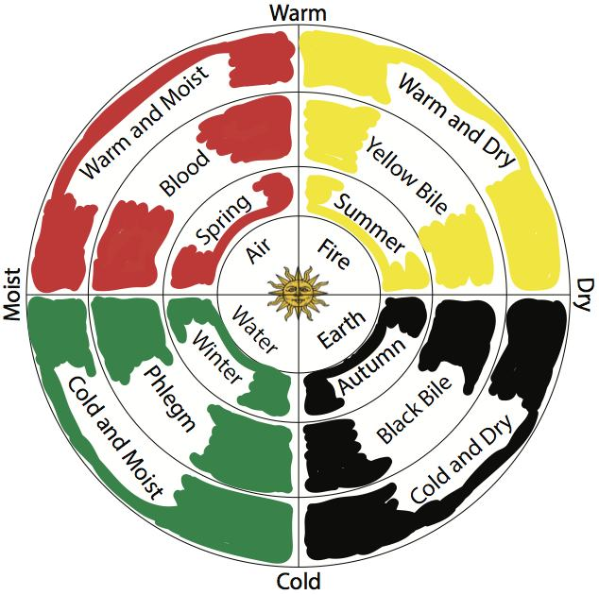
The belief was that the humours needed to be balanced and equal – if they were not then a person became ill. The theory said each humour was linked to certain characteristics e.g. a fever was caused by too much blood. The humours were linked to the seasons e.g. phlegm was linked to winter. Astrology was an important part of this was the humours were connected to star signs as well as personality traits.
The theory could be used to explain almost any kind of illness – physical or mental. There was no other scientific explanation for the cause of disease.

Miasma
A miasma was bad air that was believed to be filled with harmful fumes. Hippocrates and Galen both wrote that swamps, corpses and other rotting matter could transmit disease.
Smells and vapours were also associated with God - a sweet smelling home was a sign of spiritual cleanliness.
Medieval physicians called it ‘corruption of the air’.

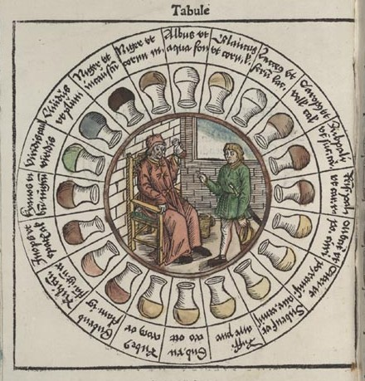
Diagnosis illness
Many Medieval doctors carried with them a vademecum (meaning 'Go-with-me') book of diagnoses and a urine chart. Usually, they examined the colour, smell and taste of the patient's urine, and made an on-the-spot guess as to what they might be suffering from. Pictures from the time make it clear that doctors also did clinical observation, and took their patient's pulse.

Why was there a continuity of ideas in the Middle Ages?
There was a lot of continuity of ideas in the Middle Ages. There were only a few small changes such as the widespread use of astrology. Mostly ideas remained the same, why?
- Hippocrates and Galen: Students were taught based on the texts of Galen and Hippocrates rather than practical experience. Their books had been preserved by Arabic scholars and by the Middle Ages Latin translations were available. Translations of these texts were copied and recorded by monks who passed them onto medical schools and universities. Galen had written that the body was clearly designed for a purpose – different parts of the body were designed to work together and he said this could only have been done by a creator; he also believed in the idea of a soul. This fitted in with the ideas of the Church, who believed that God created man in his own image and they promoted Galen’s teachings.
- The Church: The Church did not like change and wanted to keep things the way they were. Books were produced in monasteries, and libraries were maintained by the Church, they controlled which books were copied and distributed. the Church also controlled learning in universities too. The Four Humours Theory fitted in with their teachings so it promoted this theory. Medieval people had a strong belief in God and did not want to risk going to Hell by criticising the Church. Everyone knew a ‘good’ physician would follow the theory of the Four Humours – those who didn’t follow this didn’t find work.
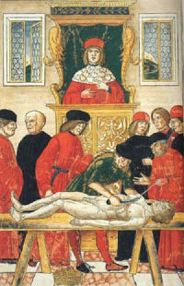
- Scientific and technology: There was a lack of scientific evidence to support any other ideas about the causes of disease. Dissections were illegal as the Church taught that the body needed to be buried whole for the soul to go to heaven. Sometimes criminals were sentenced to death by Vivisection. In the picture you can see that the physician is sitting high up, away from the body and is reading aloud from the works of Galen while the cutting and examining was done by a Barber Surgeon. Anything they found that didn’t agree with Galen could be explained away as the body was that of a criminal and therefore imperfect. Physicians and medical students tried to make new discoveries fit into the old theories, rather than experimenting to explain the discoveries.
- One important piece of technology was the printing press (1440). This led to much faster and easier sharing of medical texts but in the Medieval period it had limited impact.

Explain why there was continuity in ideas about the cause of disease in the period 1250-1500
You may use the following information in your answer:
- The Church
- Galen
You must also use information of your own. 12 marks

There are six marks here for your knowledge and six marks for how well you explain your answer.
Make sure you use your own knowledge as well as what is suggested by the bullet points
Think about your structure and whether it makes sense, think carefully about the order or your points and make links between your ideas.

Treatment and Prevention
Supernatural  If the cause of illness was God, then logically God could also cure the illness. People could cure illness by:  - Prayers and spells  - Paying for mass to be said  - Fasting (going without food)  - Pilgrimages (journeys to religious places)  - Charms and amulets  - Doing nothing – if God had sent the disease to clean the soul then it was important to let it run its course.  Astrology was also used to diagnose illness and treatments varied according to the horoscope. The alignment of the planets was checked so many treatments were done at night time. | Herbal remedies & Bathing  Common ingredients included mint, camomile, almonds, saffron, absinthe and turpentine. Some of these were expensive and difficult to find.  Another common remedy was theriaca. This was a spice based mixture that could contain up to 70 ingredients. Galen had written a book on the use of these particularly looking at treating snake bites and poisons.  Different foods were prescribed to balance the humours, e.g. chicken and almonds as the ingredients were warm and moist.  Warm baths were often prescribed to dissolve blockages in the humours. Plants and herbs were added to the bath water. Sometimes they were less pleasant – for paralysis patients were advised to boil a fox in the water and bathe in it – foxes have quick and nimble properties.
Four Humours - Bleeding  Phlebotomy (bloodletting) was the most common treatment, bad humours could be removed by removing some of the blood. It was usually carried out by Barber Surgeons or Wise Women. It could be done in different ways  - Cutting a vein: a vein was cut open with a sharp instrument. Phlebotomy charts were used to show points in the body were bleeding was recommended for specific illness  - Leeches were collected for those were traditional bleeding was too dangerous  - Cupping: the skin was pierced until it bled, a heated cup was then placed over the cut to draw out the blood.  Some patients died from blood loss but physicians were not held responsible. | 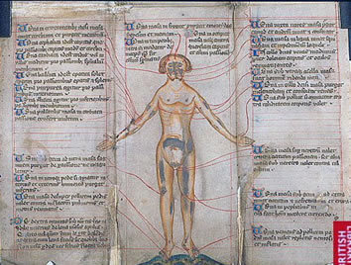
The Four Humours  Purging  It was believed that the humours were created from the foods eaten, a common treatment was therefore to remove any leftover food. This was done by giving the patients an emetic (to make them vomit) or a laxative to clear out anything left in the body. These were usually strong and bitter herbs, often they contained poisons such as hellebore. Laxatives were very common and included things like mallow leaves and linseed.  If more help was required an enema was given – a mixture of herbs and oils were squirted into a patient’s anus using a greased pipe fixed to a pig’s bladder. | 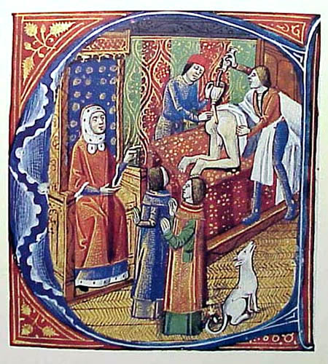
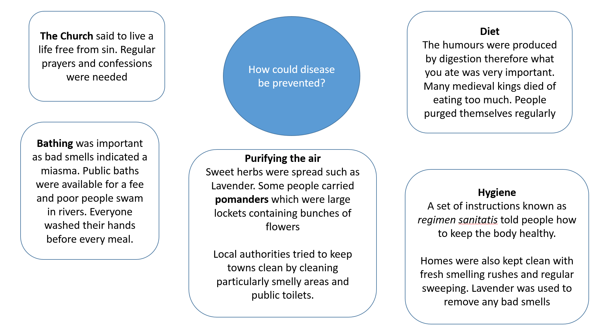
Who would you visit for treatment?
Physicians  New universities were set up across Europe making medicine more professional. A degree took between 7 and ten years to complete.  Medieval doctors were known as physicians and their main role was to diagnose and recommend treatment. They rarely actually treated the patients themselves and often did not examine the patient in person  The physician would take a sample of urine, faeces and blood. He would then consult the astrological charts and humoural charts. Many doctors were also priests so were forbidden to bleed a patient.  They were expensive as there weren’t many of them because training rook so long  Cost: £££££ | Apothecaries  They mainly mixed herbal remedies and had a good amount of knowledge, usually passed down through family. They were not as skilled or knowledgeable as physicians – they just mixed the prescribed medicines. Lots of people would see an apothecary as they were cheaper than a doctor.  They could also prescribe poisons which went against the Hippocratic Oath that doctors should do no harm. They did not have to have a formal education and could not be trusted to do no harm. Some also provided amulets and charms.  Cost: £££
Barber Surgeons  the least qualified medical professionals. They had sharp knives and a steady hand so could perform small surgeries such as extracting teeth and bleeding.  They would advertise their services by putting a bowl of blood in the shop window until 1309, after that they displayed a sign of a bandaged, bloody arm.  Some were highly trained, in Europe some doctors were surgically trained alongside medicine. They learned from practical experience instead of books.  Cost: ££ | Women  Most people were treated by women at home; this involved making the patient comfortable, preparing food and mixing herbal remedies.  Women would also grow plants known for their healing properties. There is some evidence that they also carried out minor surgery and bleeding but the records are patchy.  Cost: Free
Medieval Hospitals
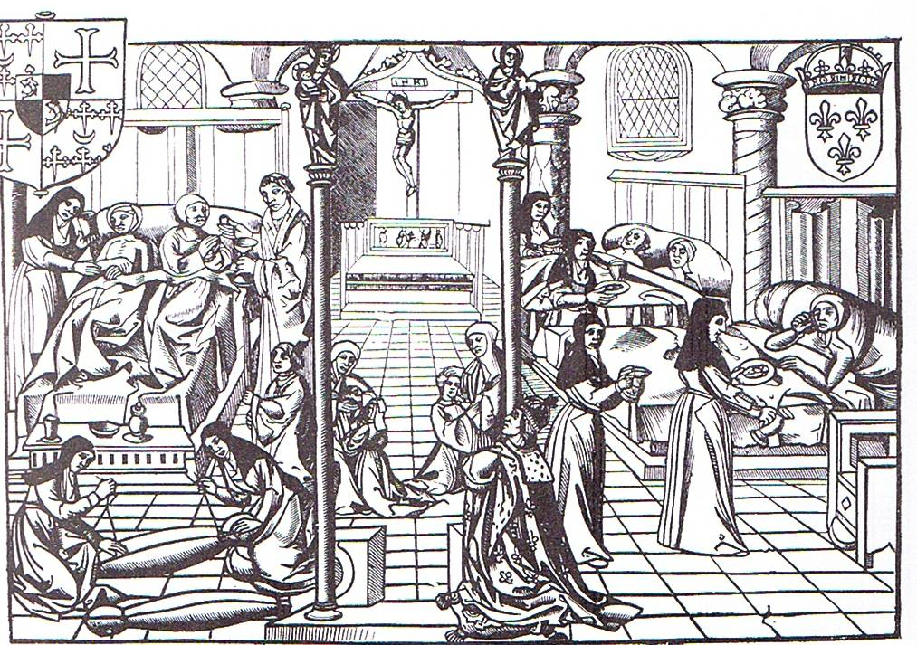

The Hotel Dieu in Paris. This was not a typical hospital as the king’s doctors worked there!

- The term Hospital comes from the Latin word “hospes” meaning stranger or guest. In medieval Europe they were originally hostels for travellers. They varied in size but usually catered for small numbers
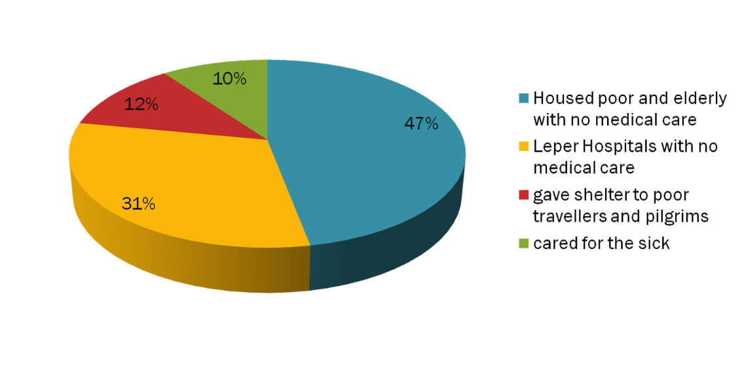
- Some hospitals specialised. Lanfranc, the Archbishop of Canterbury, founded a hospital for the sufferers of leprosy. Some specialist hospitals eg St Mary of Bethleham in London which looked after “poor or silly persons” ( later called Bedlam).
- Most were set up by the church with care provided by monks or nuns after 1100. Nearly 1200 in Medieval England and Wales. However most did not even have a doctor
- Patients were given food and a bed although they often had to share; treatments included herbal remedies but prayer was also central. Prayers were also said for souls of people who sponsored hospital. Church services held throughout day with as many as 7 in some places.

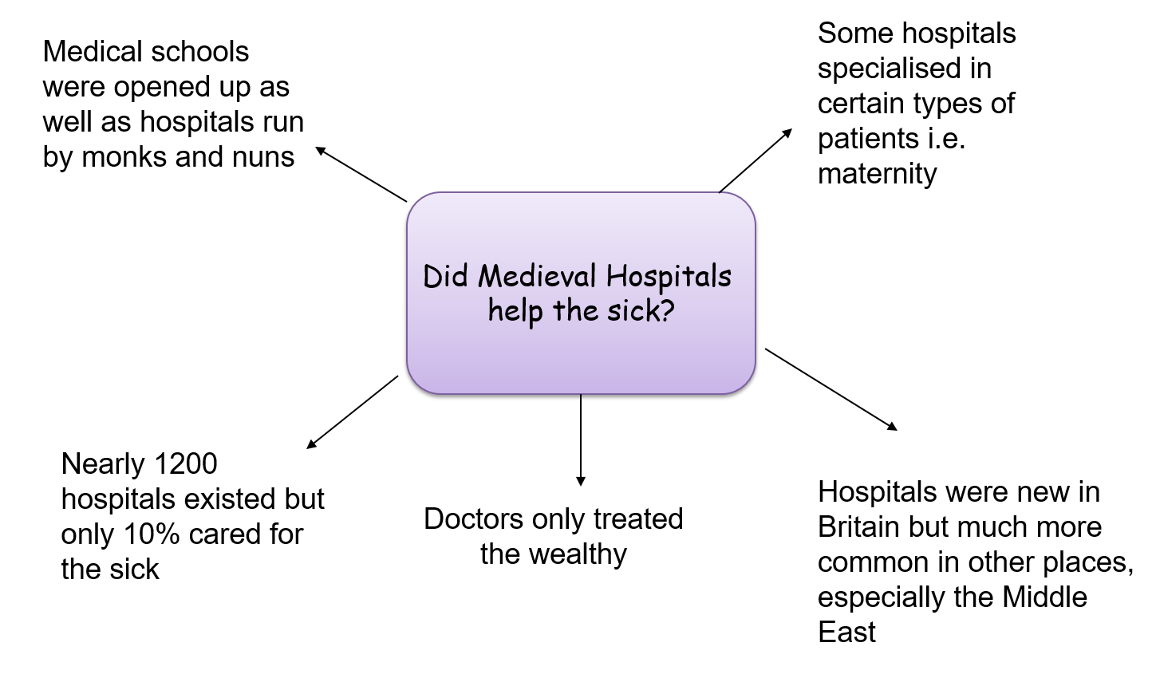

‘Hospital treatment in England in the period from 1250 to 1500 was very rare’.
How far do you agree? Explain your answer
You may use the following information in your answer
- Charity hospitals
- Care in the home
You must also use information of your own. [16 marks + 4 SPAG]

Case Study: The Black Death 1349
What was it?  The Plague first arrived in England in 1348; today it is treated by antibiotics but people in the Middle Ages treatments like this did not exist. People were totally unprepared and did not know how to prevent or treat the ‘Scourge’.  The Black Death was Bubonic Plague that was spread by fleas who lived on the rats travelling in merchant ships. It was probably spread by flea bites although though there is some evidence that some forms were spread through the air. The disease would last about 3-5 days and we think 1/3 of the population of England died.  The plague returned every 10-20 years after 1348 although it was never as severe. | 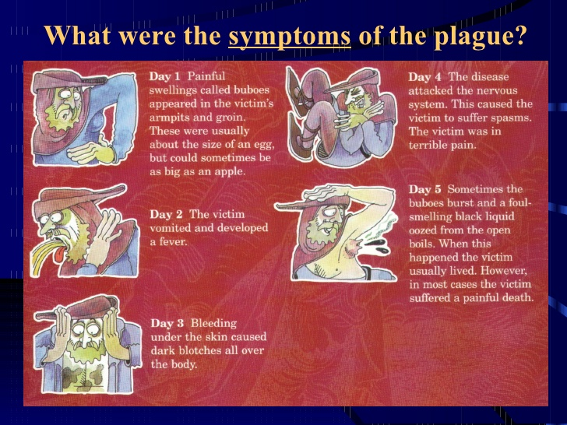
What did people think caused it?  Supernatural  - Black death was a punishment from God for the sins of man  - Mars, Jupiter and Saturn aligned in a strange way  Natural  - Miasma caused corruption to the body’s humours  - People believed that impure air came from poisonous fumes released by earthquakes or volcanos  Common beliefs  - The Jews had poisoned the wells (only in Europe as the Jews had been expelled from England in the 13th century) | 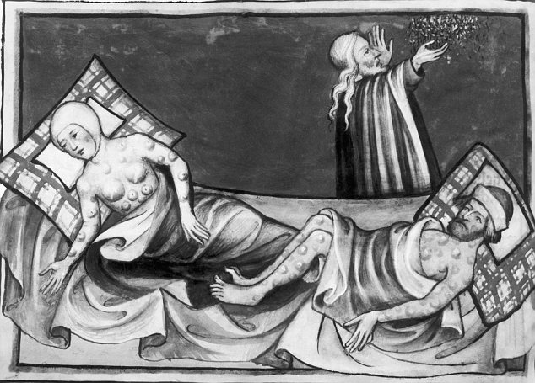
What treatments were available?  Supernatural  - Confess sins and ask God for forgiveness through prayer  Natural  - bleeding and purging  - strong smelling hers such as aloe and myrrh  - lighting a fire and boiling vinegar  - lancing the buboes  - apothecaries sold remedied and herbs | How did people try to prevent it?  Supernatural  - pray to Go and fast  - go on a pilgrimage and make offerings to God  - Flagellants who went around whipping themselves to punish themselves and prove to God that they were sorry  Natural  - Run away  - Carry fragrant flowers and herbs to avoid breathing in miasma  - Avoid bathing (water would open the pores to the infected air)  - Avoid those with the disease  Government Action  - Quarantine laws were put in place to stop people moving around  - Houses were also quarantined  - Large crowds of people were discouraged  - But they could not enforce these laws  - They also stopped cleaning the streets as they believed that the foul smell of rubbish and rotting bodies would drive away the Plague

Unit 2: The Medical Renaissance in England c.1500-c.1700
Key words
Reformation Change in religion from Catholic to Protestant
Humanism A love of learning and a belief that humans could make up their own minds about the world
Royal Charter a document from the king granting a right or power to a person or group
New World North and South America
Dysentery A stomach bug causing severe diarrhoea
Anatomy Study of how the human body works
Quack Doctor no medical training but sold remedies to patients promising to ‘cure-all’
Renaissance is shorthand for a period in European History when Ancient Greek and Roman ideas became fashionable
European exploration in Africa and the Americas led to new attitudes and a search for knowledge. Meanwhile changes in religion known as the Reformation, led to a decline in the Church’s authority, even though most people remained strongly religious
In Britain The Royal Society was set up in 1600 by educated people wishing to discuss new ideas
Governments - such as that of Henry VIII - were strong and rich. The economy boomed and trade prospered. People could afford doctors.
There was a revival of learning. Universities established schools of medicine. The Renaissance saw the beginning of scientific method - which involved conducting an experiment, collecting observations, then coming to a conclusion. People realised that the Greeks loved enquiry – asking questions, challenging old ideas and suggesting new ones. At first, scholars merely claimed that they were renewing the perfection it had amongst the ancient teachers', but soon they began to conduct experiments which led them to question the knowledge of the Greeks and Romans. This was vital for the development of medicine.

New Ideas
- Some physicians were starting to reject the Theory of the Four Humours
- New chemical treatments started to appear
- In 1564 it was theorised that disease was caused by seeds spread in the air
- In 1628 William Harvey suggested that blood was circulated around the body
- A better understanding of the digestive system was developed – people no longer believed that disease was caused by eating the wrong foods
- Urine was no longer seen as an accurate way of diagnosing illness
- In 1676 Thomas Sydenham suggested that illness was caused by external factors and not the Four Humours
- By 1683 more powerful microscopes allowed the observation of tiny ‘animalcules’ (little animals in plaque scraped from between the teeth). This was the first recorded observation of bacteria

- Although ideas were changing, the practice of medicine did not
- It was still impossible to diagnose or treat internal problems in a living patient
- A lack of quality medical instruments, such as microscopes, prevented any rapid change in people’s beliefs about the cause of disease
- General public still believed in the Four Humours Theory so physicians stuck to the old methods
- Although the power of the church was weakening, people still looked for supernatural explanations in times of Plague.
- The idea of Miasma was still widespread during this period

Why was there such a limited impact?

Explain one way in which ideas about the cause of disease and illness were similar in the 14th and 17th centuries
[4 marks]

The answer does not need to be very long but should have specific information for each time period. Try to make a point that covers both time periods e.g. miasma, and then give an example for each time period.

Thomas Sydenham
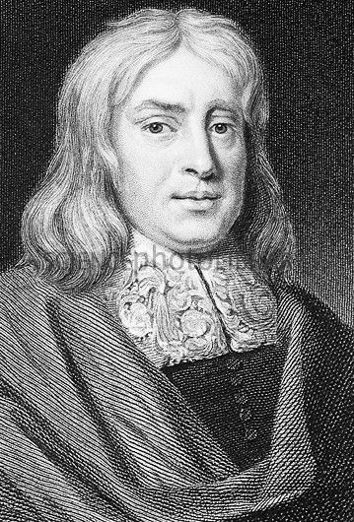
Thomas Sydenham was a physician recognized as a founder of clinical medicine. Because he emphasized detailed observations of patients and maintained accurate records, he has been called “the English Hippocrates.” Sydenham began to practice about 1656 in London, where he made an exacting study of epidemics (rapid spread of a disease). This work formed the basis of his book on fevers (1666), later expanded into Observationes Medicae (1676), a standard textbook for two centuries. His treatise on gout (1683) is considered his masterpiece.
He was among the first to describe scarlet fever—differentiating it from measles and naming it—and to explain the nature of hysteria and St. Vitus’ dance (Sydenham’s chorea – jerking movements of the hands, face or feet). Sydenham introduced laudanum (alcohol tincture of opium) into medical practice, was one of the first to use iron in treating iron-deficiency anemia, and helped popularise quinine in treating malaria. He also insisted that doctors should visit the sick, rather than the other way round, which showed some progress in his thinking - but he taught that disease was caused by 'atmospheres'

Why was The Royal Society important?
- Scientists wanted to be able to share ideas and this led to the founding of the Royal Society in 1660. Its aim was to carry out experiments to further the understanding of science and encouraged the sharing of ideas
- In 1662 they received a Royal Charter from Charles II; this meant that the king approved of and supported them. More people sent work to be published or were willing to donate money.
- In 1665 it began publishing a scientific journal called Philosophical Transactions. It was the world’s first scientific journal. This was a really important way for scientists to share their work
- It encouraged its members to write in English, not Latin, making it accessible for everybody and that copies were put into a reference library. It meant scientists could access each other’s research.

The Printing Press
- This was created in 1440 and was a machine that could print pictures and text, before this books had to be copied out by hand which made them very expensive.
- Information could now be spread very quickly and accurately. Scientists could publish and share their work.
- Before the printing press the Church had controlled all printed books, this meant most books were about religion, now a much wider variety of subjects could be printed.

Prevention and Treatments
Continuity | Change
- Bleeding, purging and sweating were used to rebalance humours  - Herbal remedies were still used  - Cleanliness was still important – but bathing was less fashionable – people were afraid of catching syphilis! They were more likely to change their clothes | - Idea of transference – an illness or disease could be transferred to something else – some people used to sleep with a sheep in the bedroom hoping that their fever would transfer to the animal!  - New plants were brought back from the New World e.g. ipecac in treating dysentery and cinchona in treating malaria  - Alchemy meant that people began to look for chemical cures for disease – metals were used as cures for ailments  - Ideas about the atmosphere causing disease were becoming more popular and people measured weather over a long period of time  - Fines were given for not keeping the street clean and removing sewage and rubbish was given as a punishment

Explain one way in which ideas about the treatment of disease were different in the 14th and 17th centuries
[4 marks]
Renaissance Doctors
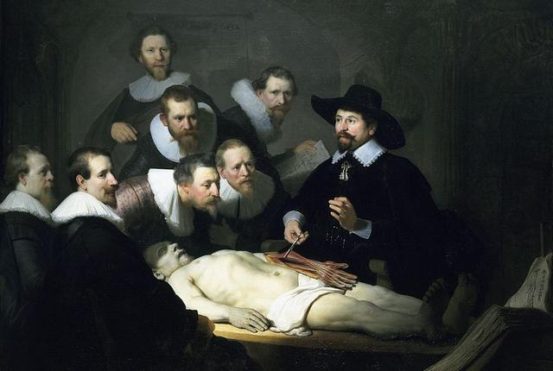
The Early Modern Age saw advances in theory, but not in practice. The most advanced Early Modern physicians were usually town-based, and also:
- were well educated and trained
- did 'scientific' research
- were prepared to contradict the accepted authority
- disseminated their findings
- relied on royal support
- had limited success
- However, they charged very high fees and only the richest people could afford them

The medicine available to ordinary people relied on the amount they could afford. The people they turned to for medical advice included:
- country doctors - lower fees than town doctors, but not well-trained
- barber-surgeons - who were paid to perform small operations
- apothecaries (chemists) - no medical training, but sold medicines and groceries
- quacks - travelling barbers, tooth-pullers, who sold medicines which were supposed to cure everything
- wise women, neighbours and local 'witches'
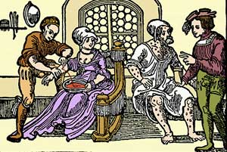

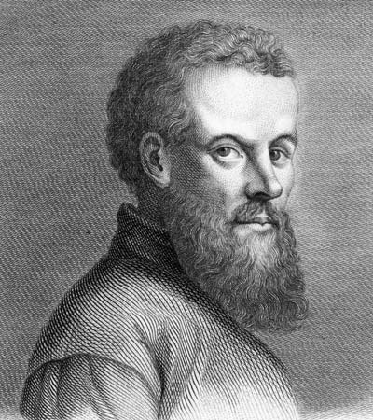
Andreas Vesalius
Vesalius came from a family of physicians and his father and grandfather had served the Holy Roman Emperor. He studied medicine in Paris and Padua, a very famous university.
He produced diagrams labelling the different parts of the human body. He was able to dissect the corpses of executed criminals and make detailed drawings.
In 1543 he published his book, On the Fabric of the Human Body, this showed that Galen had made several mistakes (Galen had only dissected animals). He corrected over 300 of Galen’s mistakes including:
- the human jawbone is in one part, not two
- the main vein leading out of the heart did not lead to the liver
- the human liver did not have five separate lobes
He encouraged other doctors to dissect and, although it had little practical impact on everyday medicine, it led to others investigating the anatomy of the human body in more detail. Renaissance artists produced exceptionally detailed drawings for his books.

Why is he important?
- He made the study of anatomy fashionable and a central part of the study of medicine. Doctors, rather than surgeons, now carried out dissections.
- His work was copied and appeared in other medical texts
- Inspired other anatomists, some later corrected his mistakes
- BUT Traditional doctors were angry that he criticised Galen – they said that the body had changed since the time of Galen.

‘Individuals had the biggest impact on medical training in the 16th and 17th centuries’
How far do you agree? Explain your answer
You may use the following information in your answer:
- Vesalius
- The Printing Press
You must also use information of your own. [16 marks + 4 SPAG]

When answering a question based on an individual don’t tell the story of what they did. Instead focus on what their discoveries did to medical progress – use connectives such as this led to, this allowed them to, it enabled…to help explain your points
Case Study: William Harvey
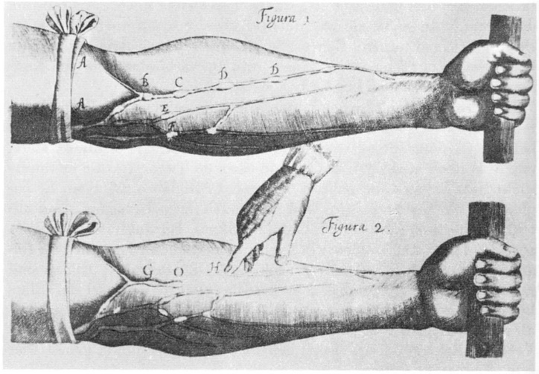
What did Harvey prove?
- Harvey explained how blood flowed in one direction throughout the body and that it was in the lungs where the transformation of venous blood to arterial blood took place. He used Vesalius’ theory that the veins contained valves, proving the blood flowed towards the heart. When he tried to pump liquids through the veins the other way, it did not work.
- He dissected human corpses and cut open cold blooded animals to observe the movement of the blood.
- He proved that the arteries and veins were linked together in one system. This was done by tying a cord around an arm and cutting off the blood flow.
- Galen had said that blood flowed through the heart and that the veins carried blood and ‘breath of life’ (the soul) and the arteries carried just blood. Harvey proved that there were no holes in the heart, that the veins carried just blood and the heart acted as a pump.

What helped Harvey?
Individual Genius: Harvey was a talented man and built on the findings of other doctors such as Vesalius
Science and Technology: The development of mechanical fire pumps helped Harvey to develop his ideas; also dissections were becoming more common
Government: Harvey was employed by Charles I – lots of people heard about his theories as he had royal support

How important was he?
- He encouraged other scientists to experiment on bodies
- His book, An Anatomical Account of the Motion of the Heart and Blood in Animals was widely read
- Paved the way for modern understanding of anatomy

But
- His discoveries had little practical use in medical treatment
- A lot of doctors ignored and criticised him

Hospitals and Community Care
Hospitals  Improvements were made since the Middle Ages:  - People got well fed  - Doctors would visit the patients to observe and prescribe treatments  - Many had pharmacies and apothecaries to mix medicine  BUT…  When Henry VIII closed down the monasteries after 1536 many hospitals closed as they had been attached to the monasteries and healthcare was given by the monks and nuns. Some smaller hospitals reopened but it took a long time for the numbers to be restored | Pest Houses  These were hospitals that specialised in a particular disease – as the contagion of disease began to be understood specific hospitals opened to treat the plague or smallpox.  Traditional hospitals still did not admit contagious patients but these patients had to go somewhere.
Women  Most people continued to be treated at home and women played an important role on treating the sick.  Some were prosecuted for practising medicine without a licence. They usually mixed and sold simple herbal remedied to purge the body and cure a particular ailment.  This was still cheaper than a physician or apothecary. | 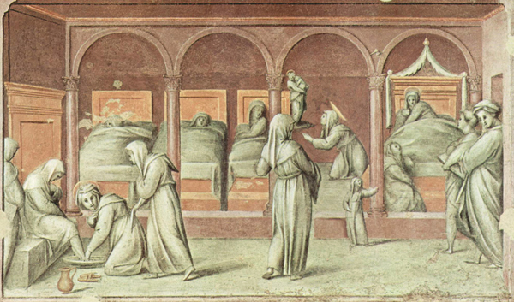

Case Study: The Great Plague 1665
- Lasted from June to November
- 100,000 people died in London (1 in 5 people)
- They still didn’t know what caused it so they blamed…
    - The alignment of Saturn and Jupiter and between Mars and Saturn. A comet was also spotted
    - God was punishing them
    - The most popular theory was miasma causing by stinking rubbish on the streets
    - Person to person infection
How was it treated?
- Quarantining victims in their homes
- Wrapping victims in woollen clothes and lying them by the fire – sweat it out
- Transference – strapping a live chicken to a buboes to draw out the poison
- Herbal remedies
- Quack remedies
- Pray
- Quarantine anyone with the plague
- Carry a Pomander (a ball containing perfumed substances)
- Fasting or eating a garlic heavy diet

Doctors said…
- Apothecaries prescribed ‘plague water’
- Use mint and rosemary or sugar and nutmeg
- Smoke tobacco
- Catching syphilis would prevent the plague

Other healers said…

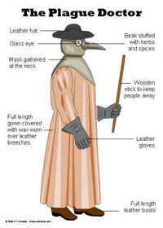

The birdlike masks were stuffed with herbs to ward off the miasma. It was shaped like a bird because it was believed that birds attracted the disease, therefore would leave the patient alone.
The wax cloak would be wipe clean (think about the symptoms of the plague)

Did the government help?
- Charles II said everyone should fast regularly
- Public meetings and theatres were closed
- Streets and alleyways were swept and cleaned
- Fires were set to burn on streets to drive away the miasma
- 40,000 dogs and 200,000 cats were slaughtered
- Searchers and wardens checked for plague victims and quarantined the houses. Houses were painted with a large red cross. Carts would travel through the streets and collect dead bodies
Explain one way in which ideas about preventing the plague were different in the 14th and 17th centuries [4 marks]
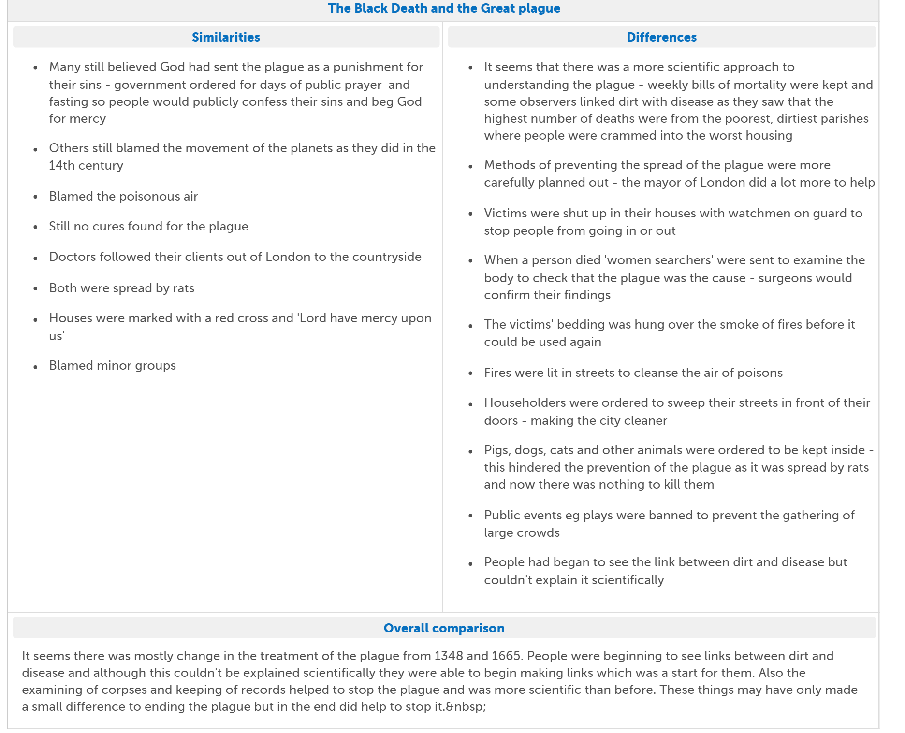

Explain why there was continuity in the way disease was treated in the period c.1500-1750. You may use the following in your answer:
- The Great Plague
- Attitudes in society (resistance to change)
You must also use information of your own [12 marks]
Unit 3: Medicine in 18th and 19th century Britain (1750-1900)
Key words
Inoculation giving somebody a small dose of a disease to create immunity.
Vaccination creating antibodies against a disease
Spontaneous Generation a belief that decay caused germs to appear
Pasteurisation Heating liquid to kill germs
Bacteriology the study of bacteria
Cholera disease causing severe vomiting, diarrhoea, dehydration and death
Antiseptic kills germs on a wound
Aseptic a germ free environment
Pharmaceutical Using drugs for medicine
Anaesthetic Making the patient unconscious
Gangrene death of body tissue
Antibodies particles inside the body that can identify and fight off germs
Laissez-faire governments who do not get involved in the lives of their people
Epidemic a widespread outbreak of a disease
Cesspit a pit for storing sewage
Case Study: Edward Jenner and Vaccination
How did people prevent smallpox before vaccination?
Lady Mary Wortley Montague witnessed inoculation in Turkey in the early 1700s. She had nearly died from smallpox when she was younger and was keen to protect her children.
She had them inoculated in 1721. this idea quickly became very popular in Britain and people had smallpox parties where they would be inoculated together.
Doctors could make a lot of money for this (only the rich could afford it) but it did not completely solve the problem because not everyone could afford it and inoculation was not always effective or very safe.

Edward Jenner
Edward Jenner was born in Berkeley, Gloucestershire on 17 May 1749, the son of the local vicar; as a young boy he was inoculated with smallpox and his experiences made him determined to find another way to prevent this disease. He trained as a doctor in London and then returned to Gloucestershire to become a local doctor. During this time, he gathered evidence about where the inoculation had failed (over 1,000 cases).
Jenner noticed that milkmaids who got cowpox (a weaker version of smallpox causing blisters) did not go onto to develop smallpox and thought that the two must be connected.
A local milkmaid, Sarah Phelps, came to him with cowpox and Jenner used the cowpox matter to inject into eight-year-old James Phipps. Six weeks later he inoculated James with smallpox but James did not catch it. He repeated this experiment several times on both James and local people.
In 1798 he wrote up his findings in An Enquiry into the Causes and Effects of the Variola Vaccinae, and named his technique ‘vaccine’ after the Latin word Vacca, which means cow. He sent his findings to the Royal Society (who refused to publish it) and made sure his instructions were very clear so other doctors could follow them.
How does it work?
Cowpox is almost the same virus as small pox so when the body reacts to cowpox it also becomes immune to the very similar disease of small pox but Jenner did not know this because there were no powerful microscopes so he could not observe the virus. Vaccination was the result of careful experimentation.
How did people react to Jenner’s discovery?
People opposed Jenner because…
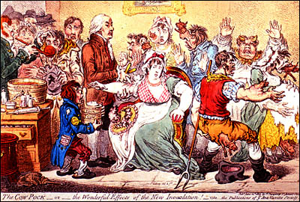
- The link only existed between smallpox and cowpox. It did not work for any other disease. Other scientists couldn’t use this method to develop other vaccines
- Jenner could not explain how the link between cowpox and smallpox worked
- Vaccination was not always successful and some people developed smallpox because some doctors were not careful enough
- The government provided a grant to pay for free vaccinations but doctors lost money because people no longer paid for inoculations
- The church said that using animal matter to protect against human diseases was against God’s will

BUT…
- From the 180s onwards the British government supported this method of vaccination. It was safer, more reliable and cheaper.
- It became very popular in Britain; the Royal Jennerian Society, was founded in 1803 and vaccinated 12,000 people in two years
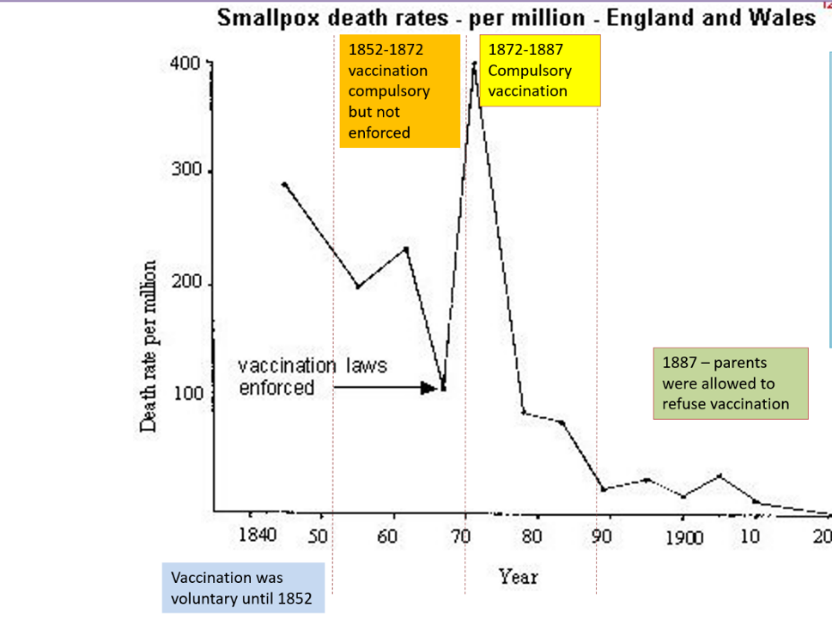
- Napoleon vaccinated his entire army in 1805
- After 1872 the government enforced compulsory vaccination.
- In 1979 the World Health Organisation announced that the disease had been completely wiped out

Explain why there was rapid change in the prevention of smallpox after 1798. You may use the following in your answer:
- Inoculation
- Government
You must use information of your own [12 marks]
The Germ Theory
What ideas did people have about the causes of disease by 1750?
During the Renaissance there had been a growing interest in Science. By the 18th century (1700s) they were less likely to blame disease on supernatural causes or unbalanced humours.
People had always been aware that diseases spread quickly in dirty, smelly and unhygienic conditions, and so the search for a new explanation of illness now developed into two main theories:
Bad air (miasma)
People could see rotting food and waste in the streets and knew they smelt terrible.
They assumed it must be the smell that caused disease
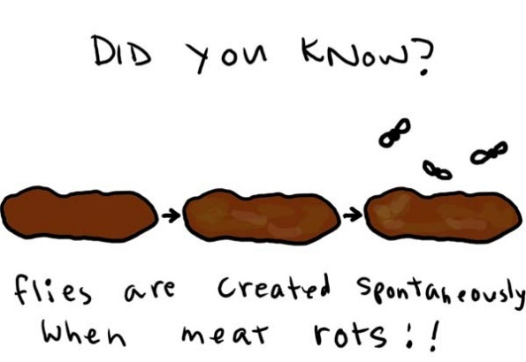
Spontaneous Generation!
The latest theory. The microscopes picked up bacteria on decaying matter.
Scientists thought that the germs were spontaneously (automatically) generated (created) by the decay and then spread the disease further.
Spontaneous Generation!

Enter Louis Pasteur…
First scientist to identify microbes and their role in disease
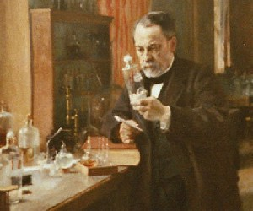
In the 1850s Louis Pasteur, a French Chemist, (not a doctor!) investigated the problem of liquids turning sour in the brewing and vinegar industries
More powerful microscopes had recently become available, which meant that Pasteur could observe the growth of unwanted small organisms in the liquids
He discovered that heating the liquid killed the bacteria and stopped liquid going sour. This is called Pasteurisation
In 1861 he published his Germ Theory, showing that there were microbes in the air and that they caused decay.
His work proved the idea of spontaneous generation was wrong because no decay happened if matter was placed in a sealed contained. This showed the microbes causing decay were not produced from the matter itself but from the air around it

What was his impact?
Remember that Pasteur was not a doctor – his work focused on decay, not disease, so had very little impact straight away. In Britain people continued to believe in Spontaneous Generation until the 1870s-powerful doctors continued to promote this. Some scientists and doctors started to promote it such as Joseph Lister, who linked germs to surgical infections.
A scientist called John Tyndall discovered particles in the air and linked his discovery with Pasteur’s germ theory and Lister’s work on wound infection. He believed that dust particles carried germs. However, he was a scientist and people did not trust him. Lister was also doubted as bacteria could not be identified – this caused problems working out what bacteria led to which illness and also the fact that even healthy people had bacteria living on them.
Therefore, attitudes amongst doctors in Britain meant people refused to recognise the link between germs and disease.

Robert Koch – father of bacteriology
Identified the different germs that caused disease
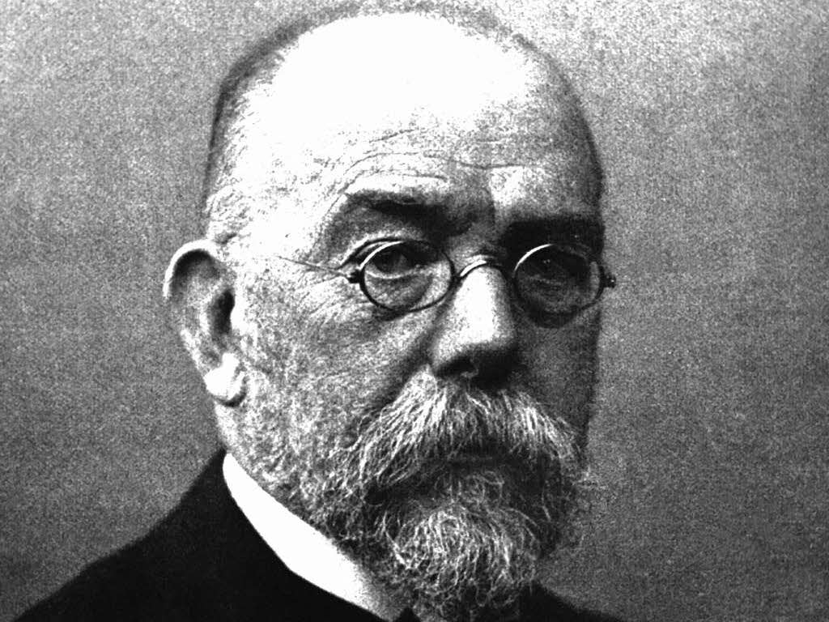
In 1882 Koch discovered the bacteria causing Tuberculosis (TB). He published his methods in identifying disease-causing microbes:
In 1883 he discovered the bacteria causing Cholera and proved it was spread through water.
He was also important for developing techniques in growing bacteria using agar jelly. He also developed methods of staining them to make them easier to see.
He inspired other scientists to find microbes for other diseases.

What was his impact?
Only once the specific disease causing microbes had been found could work begin to find cures and vaccines. Even the British government rejected the Germ Theory – even when Koch proved that Cholera was spread in the water supply he was ignored and the British government clung onto the idea of miasma.

However, bacteriology and the germ theory had an enormous understanding on the cause of disease and illness. The mystery had been solved, even if it took the medical profession a while to accept this, and new treatments could now be researched.

What factors affected the understanding of the cause of illness and disease? | Individuals  Without Pasteur and Koch it would have taken a lot longer for the Germ Theory to be developed
Government  The government did not help improve understanding in the cause of disease.  After 1867 more people in Britain had the right to vote so the government had to listen to them but were only interested in practical solutions; the Germ Theory actually offered no practical solutions. | Technology  The microscope was a very important piece of technology – it allowed scientists to spot most micro-organisms.  Koch also developed new techniques of growing and staining bacteria.
Science  Improved communications allowed scientists to share their work with each other and there was a desire to prove new theories and find practical solutions | Changes in Society  People were more interested in finding the reasons behind disease than they had been in previous centuries. They were looking for rationale explanations and links were made between unhealthy living conditions and disease.  However, people were reluctant to change their minds and it took a long time to accept the germ theory. Until the 1880s, when it could be proved that the same microbe was present in disease, the germ theory was not accepted.

The development and use of vaccinations
Pasteur admired Jenner and started to look for vaccines that would tackle lots of diseases; however, Jenner’s results had been through observation and experiments, not through the use of microbes. Pasteur realised that vaccines could only be developed once the germs causing that specific disease had been identified.
In 1879 Pasteur’s team was studying chicken cholera microbes. A culture was accidentally left on one side and a couple of weeks later it had become a weakened version, which didn’t harm the chickens. Pasteur realised this could be used as a vaccine to create immunity from the disease for chickens. He called this process ‘Vaccination’ after Jenner.
In 1879 Pasteur continued his work by providing a vaccine for anthrax, a disease that affected animals. This was followed by one for rabies.
Pasteur’s vaccine’s involved producing a weakened version of the culture and the treating the patients with it. This created antibodies; Pasteur couldn’t explain how this worked but it clearly did. Until this point, his work had little direct impact on disease in humans but it did inspire other scientists to look for human vaccines. Koch’s work on identifying bacteria was very important in this – in 1890 vaccines were developed against tetanus and diphtheria. By 1900 scientists all over the world were isolating microbes and developing vaccines thanks to the work of Pasteur and Koch.

‘There was rapid change in ideas about the causes of illness and disease in the period c1700-1900’
How far do you agree? Explain your answer
You may use the following information in your answer:
- Spontaneous Generation
- Louis Pasteur
You must also use information of your own. [16 marks + 4 SPAG]
Two hundred years is a long time and there was not rapid change throughout all of this time– in your answer try to pinpoint where you think the rapid change occurred (1860s-1880s). Make sure you explain your ideas.
i.e. the belief in spontaneous generation and miasma proves that very little changed until the 1860s – even after Pasteur’s germ theory there was still little change until Koch published his findings in the 1880s.

The changing role of women in medicine
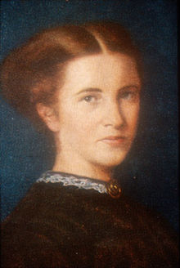
Women had always been important in medicine and were very knowledgeable about herbal remedies. A new law in 1852 said that all doctors had to belong to one of the College of Surgeons, Physicians or Apothecaries. All of these were closed to women. A handful of women did fight to become doctors such as Elizabeth Garrett, the first woman to qualify as a doctor in Britain. She applied to the College of Apothecaries (the only one of the three medical bodies that did not state that they would not accept women).
They refused to accept her but her father took them to court. In 1865 they agreed to register her (but changed their regulations afterwards so that other women could not copy her).
She was, however, an exception. Most male doctors were opposed to women doctors, and each time a woman found a loophole that allowed her to progress in her career, the medical profession changed the rules to stop it happening again. In 1911 there were only 495 women on the Medical Register in Britain.

What were hospitals like in 1800?
Wards were not cleaned frequently – death rates from infections were high
The wards were stuffy and cramped and helped infection spread easily

Nursing staff were not trained and poorly educated
There were few toilets and poor sewage systems
Doctors did not wash their hands or change their clothes
Nurses were often dirty and drunk

In 1854 the Crimean War broke out against Russia. British troops found themselves fighting in mud and freezing temperatures. The death rate from disease and infection was enormous; Britain had inherited a hospital barracks at Scutari from the Turks. It was filthy, damp, smelly, and overrun with rats. The medical service was inefficient and wholly ill-prepared for the conflict. Teams of men designated to carry the wounded from the battlefield were mostly drunk, idle and incompetent. Cholera, dysentery and gangrene killed more men than the fighting.
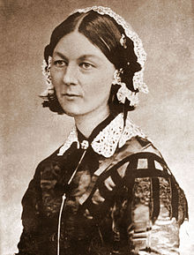
Florence Nightingale
Background
Florence Nightingale was born into a wealthy family but decided she wanted to be a nurse. Despite her family’s resistance she was able to train in Germany and returned to become Superintendent of Nurses in a London hospital.
When she heard reports of the terrible conditions in the Crimea she talked to Sydney Herbert, the minister for war, and a family friend. He agreed to let her take 38 nurses to the Crimea

In the Crimea
When she arrived at the hospital in Scutari she was horrified by the conditions she found there. She made changes to take care of the wounded soldiers:
- Scrubbed the hospital wards thoroughly
- Nurses were organised and could treat 2,000 patients
- Clean bedding and good meals
The death rate fell from 40% to less than 2% within six months and Florence returned home a hero.

After the Crimea
Florence changed the way the hospitals were designed, with better ventilation, more windows, larger rooms and isolation for infectious diseases. They were built out of materials that could be easily cleaned.
She also set up a nursing school at St Thomas’ hospital in London called the Nightingale school for nurses. Training focused on hygiene and cleanliness to prevent infections and diseases spreading in hospitals.
In 1859 she wrote her book Notes on Nursing, which set out the role of the nurse and the importance of proper training.
Nursing became a respectable occupation and ‘Nightingale nurses’ were often middle class women; this removed the reputation of drunk and uncaring nurses. Proper training turned it into a profession rather than an unskilled job and the number of nurses quickly increased.

By 1900 hospitals were very different…
- Separate wards were created
- Operating theatres and different departments
- Cleanliness was important
- Doctors were common; trained nurses lived in nearby accommodation
- The function had changed from a place of rest to a place of treatment.

How did the workhouse system lead to an improvement in medical care?
A large number of old, sick, blind, deaf or disabled people, or those with mental illness were sent to the workhouse. There was increasing pressure to improve the condition of hospital care The government ordered that separate infirmaries were built with a full time doctor. New asylums for the mentally ill and fever houses for those with infectious diseases were built. These infirmaries went on to become major general hospitals with specialist doctors

Patent Medicines and Pharmacies
As people moved to the towns there was less reliance on herbal remedies.
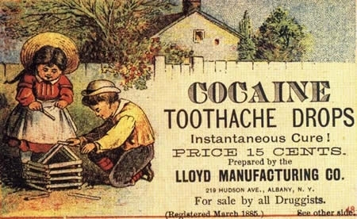
Many apothecaries sold ‘preparations’ which were advertised as a cure for everything. They were potions, ointments and pills made from coloured liquids, alcohol, lard, wax, turpentine, ginger and arsenic.
A home medicine encyclopaedia of 1910 recommended cures that included electrical shocks, injection with animal hormones, and a range of harmful substances including cocaine, mercury, creosote and strychnine.
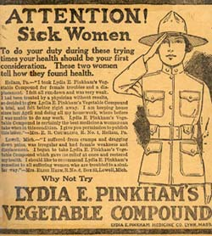
Other alternative medical treatments included mesmerism (hypnotism), homeopathy (taking tiny doses of poisons), 'health reform' (a religious movement which recommended a healthy lifestyle - it was run by John Kellogg whose brother invented cornflakes) and Christian Science (which taught that disease only existed in the mind).
Travelling 'quacks' sold patent medicines (such as Lily the Pink's medicinal compound).
The use of pills in medicine was revolutionised in 1844 with the invention of a machine to make standardised pills
By the late 19th century Thomas Beecham was selling pills and Jesse Boot had opened a chain of pharmacies. By the end of the century the government had stopped many harmful ingredients being added
The growth of the chemical industry meant that companies could produce their medicines on a national basis and used advertising in newspapers and on posters to increase their sales. This became the pharmaceutical industry.

Developments in surgery in the 19th century
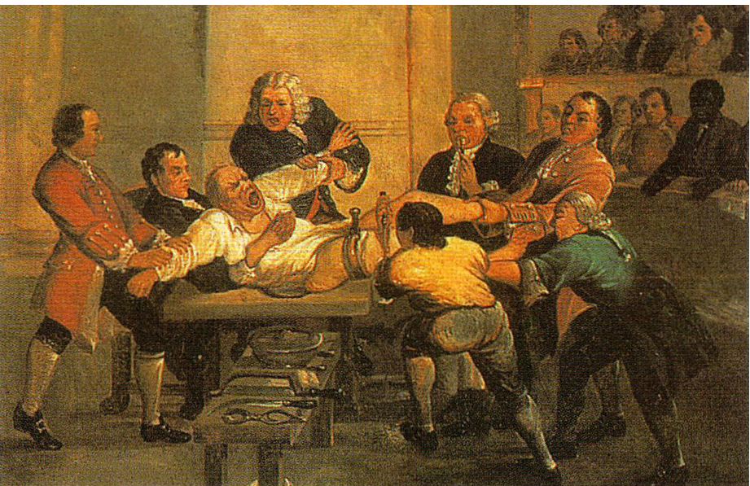
What were the key problems of surgery in the early 19th century?

Pain | There were a few ways of reliving pain (e.g. opium) but without anaesthetic there was no way of preventing the patient suffering excruciating pain. This could often send the patient into shock and made it difficult for the surgeons who had to work quickly on a moving patient.
Infection | Before the germ theory there was no idea of how infection spread, even if a patient survived the operation then infection was likely to set in. Surgeries were not performed in a germ free environment and often performed in the patient’s own home.
Bleeding | Surgeons had to be quick as there was no way of replacing lost blood and this could quickly send a patient into shock. This remained a problem until blood groups made transfusions possible at the start of the twentieth century.

#1 Pain: The Development of Anaesthetics
Before the 19th century there was no effective method at reliving pain during surgery; the patient was held down or tied down by the surgeon’s assistants. Surgery without anaesthesia had to be fast. Napoleon’s surgeon amputated 200 limbs in 24 hours at the Battle of Borodino in 1812. During the 18th and 19th centuries, scientists experimented with the properties of chemicals and the effect they had on humans.
In 1799 Humphrey Davy (who later invented the safety lamp for miners) discovered that pain could be reduced by using laughing gas, but this did not make the patient completely unconscious.
Ether was later found to put patients to sleep, and was used successfully as an anaesthetic. However, it could cause the patient to cough or vomit, not ideal when a surgeon is cutting them with a knife! It was also highly inflammable.

James Simpson and Chloroform
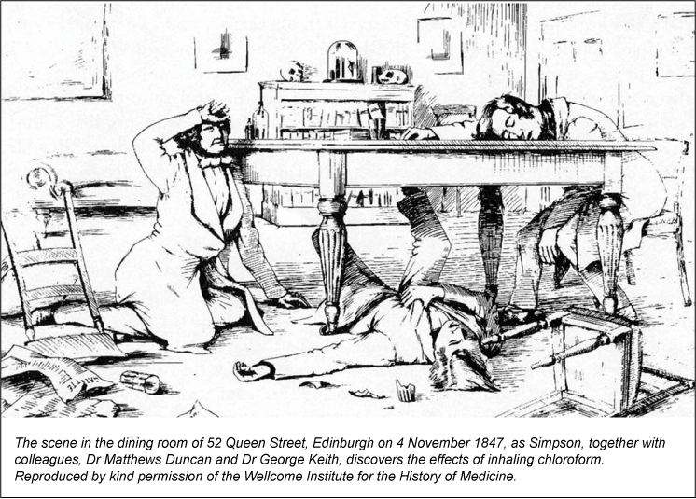
James Simpson was a doctor at Edinburgh University. He has used Ether but was hoping for a better anaesthetic. He gathered a group of friends together and they inhaled the vapours of various chemicals to see what might work. After sniffing chloroform, they all passed out and Mrs Simpson discovered them under the table.
Simpson realised it was an effective anaesthetic and within days starting using it to help women in childbirth. He wrote about his discovery and other surgeons started to use it in their operations
Why did people oppose it?
- The dose had to be carefully controlled – in 1848 14-year-old Hannah Greener died from an overdoes after having an infected toenail removed.
- It also allowed surgeons to operate deeper into the body – the led to a black period on surgery, when more people died as bleeding an infection became much bigger problems.
- Nobody knew what the long term effects would be.
- The Victorians believed that pain relief was interfering in God’s plan, particularly in childbirth, which was meant to be painful. The opposition was only overcome in 1853 when Queen Victoria used it during the birth of her eighth child.
- Doctors were worried that patients were more likely to die if they were unconscious – rather than awake and screaming!
Over time the use of anaesthetics improved, other chemicals were used to relax muscles as well as putting patients to sleep. New chemicals had fewer side effects than chloroform. Local anaesthetics were also developed – these took time but Simpson’s discovery of chloroform was a turning point.

#2 Infection: the development of antiseptic surgery
Before the Germ Theory was established there was a lack of understanding about germs. Operating theatres and surgeons themselves were dirty; in fact, the dirtier a surgeon’s coat was – the more experience he had! Surgical tools were not washed and lots of people regularly watched operations. Gangrene was common and killed many patients after the operations.

Joseph Lister
Joseph Lister had studied Pare’s work and suggested that microbes in the air were causing infections in humans. He started to look for a chemical that would clear bacteria – Carbolic Acid was commonly used in treating sewage and realised if it treated the smell of sewage it might have the same effect on wounds. In 1865 he operated on a patient with a broken leg and used bandages soaked in carbolic acid to cover the wound.

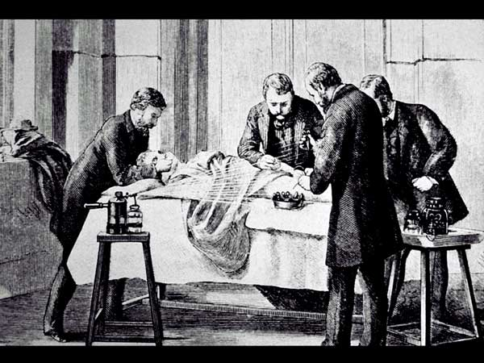
From this he developed the use of Carbolic Spray, which was sprayed in the air during operations.
He published his results in the medical journal, The Lancet, showing that he had reduced infections by 30%.

Why did people oppose it?
- The Germ Theory was not fully accepted so not all surgeons were willing to use carbolic spray – they did not believe in germs.
- Carbolic spray cracked the surgeon’s skin and made everything smell. This was unpleasant for the surgeons
- Surgeons still focused on speed – Lister’s antiseptics slowed things down
- Some tried to copy Lister’s methods and got different results, they were less systematic. Some argued it actually stopped the body’s own defences from working
- Surgeons were trained with the idea that many of their patients would die, they couldn’t accept Lister’s results – they also didn’t want to believe that they might have been responsible for the infections killing patients
- Lister was always changing his methods to try and improve on antiseptic surgery, other doctors said that he was changing his ideas because they did not work.

What was the impact?
- In the short term, surgery did not change that much because of the opposition
- In the Long term, attitudes changed and more antiseptic methods were developed
Although it was a significant development, it was only popular for a brief time and even Lister stopped using it in the 1890s. However, it changed the attitude of surgeons towards antiseptic and aseptic surgery.
By the 1890s Lister’s antiseptic methods had developed into aseptic surgery which meant removing all possible germs from the operating theatre. This was done by:
- Cleaning all operating theatres and hospitals thoroughly
- Steam cleaning instruments
- Rubber gloves and surgical gowns were introduced
- Face masks for surgeons

Explain why there was rapid change in surgical treatments in the period c1700-c1900.
You may use the following in your answer
- Chloroform
- Joseph Lister
You must also use information of your own. 12 marks

Try to avoid just describing anaesthetic and antiseptics – focus on how they helped the development of surgery

Public Health in the 19th Century
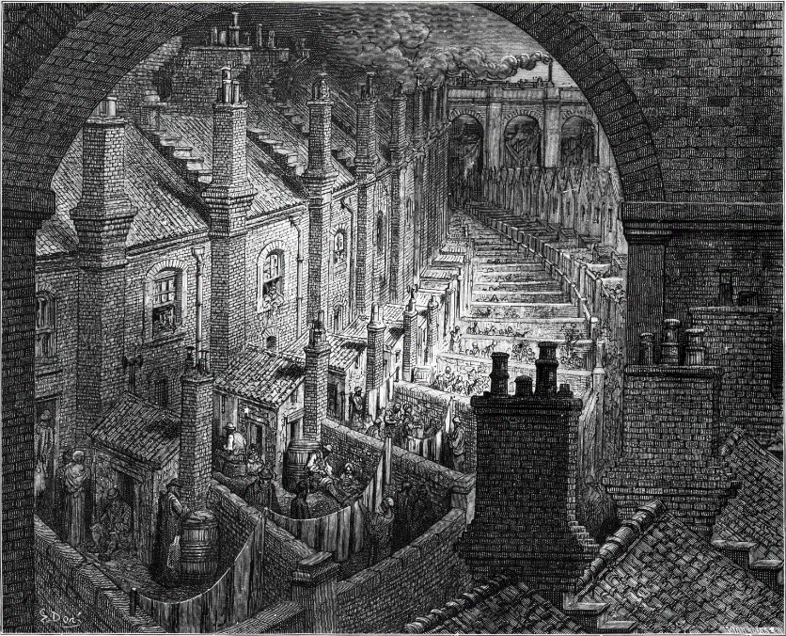
What were the problems?
- Towns grew very quickly so houses were built very quickly and cheaply
- Overcrowding
- Regular outbreaks of epidemic diseases
- Open sewers
- Rubbish on streets
- Not enough toilets
- Fresh water came from street pumps and often got contaminated with sewage
- In the 1700s the government had little interest in improving living conditions. This was called Laissez-Faire, which means ‘leave be’. The government believed that poor people were responsible for their own situation and therefore had to improve it themselves.
- By the 1800s this attitude began to change, working class people now had the right to vote so the government had to listen to them. As well as this cholera arrived in Britain in the 1830s.

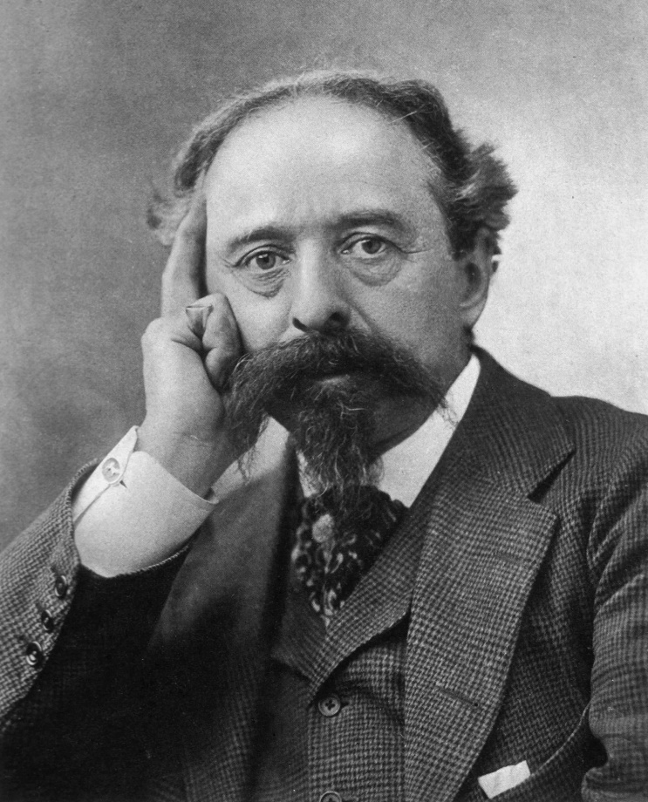
Edwin Chadwick
In 1842 he published his Report on the Sanitary Conditions of the Labouring Classes. He proved that:
- The poor lived in dirty, overcrowded conditions
- This caused a huge amount of illness
- Many people were too sick to work and became even poorer
- Therefore, other people had to pay higher taxes to help the poor.
- Improving the lives of the poor would actually cut taxes and save money

He recommended that:
- Drainage and sewers were improved
- Rubbish was removed from streets and houses
- Clean water supplies
- Medical officers to check these things happened

Case Study: Cholera 1854
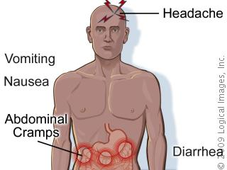
Cholera is a severe, infectious disease of the small intestine. It is marked by heavy diarrhoea, vomiting, and muscle cramps and can result in coma and death. For centuries, it was confined to India, but in the early 19th century it began to spread to other parts of Asia, Europe, and the Americas.
The disease is caught by taking in food or drink—usually water—that is contaminated with a bacteria found in faeces. After cholera bacteria are swallowed, they multiply in the small intestine, where they set off an infection.
Cholera first arrived in Britain in 1831 and returned regularly throughout the century. The next major epidemics were in 1848 and 1854.
It mainly affected the poorest people but the wealthy were also affected. Doctors found it impossible to treat.
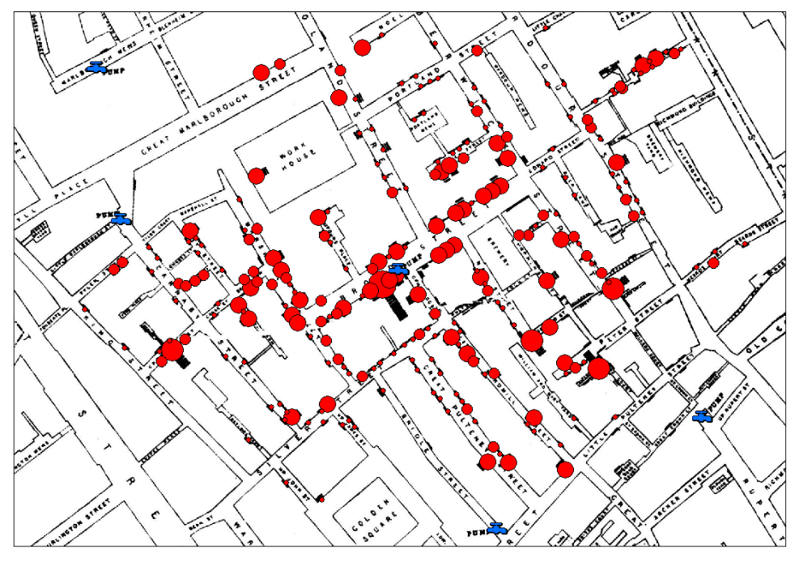
People still believed that miasma was causing the disease, in 18484 the government passed the First Public Health Act which encouraged local areas to set up a Board of Health and provide clean water. However, this was not compulsory and costed money so most places ignored this.
John Snow
John Snow was London’s leading anaesthetist (someone who gives anaesthetic) and it was him who had given Queen Victoria chloroform during the birth of her eighth child.
His main contribution though was the study of Cholera. In the 1848 epidemic he suggested that cholera could not be transmitted by miasma as it affecting the gut, not the lungs and that it was spread through dirty water. However, he had no evidence to support this until 1854.
The 1854 epidemic
There were over 500 deaths around Broad Street where Snow worked. Snow mapped out the deaths in detail and showed that there was a pattern – the number of deaths were centred around the Broad Street water pump.

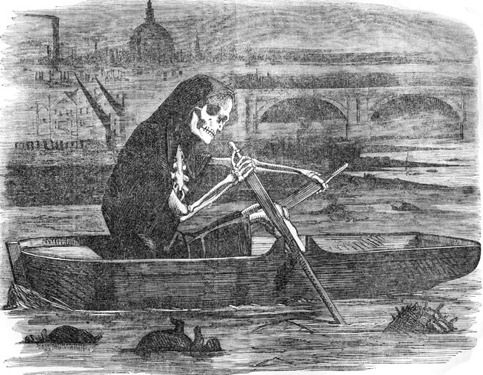
Snow proved that:
- In families that were nearer to another water pump there had been only 10 deaths. These ten had all drunk from the Broad Street pump
- Eighteen factory workers near the pump had died
- Residents of a local workhouse, who had their own water supply, were not badly affected
- No workers at the local brewery died as the workers drank beer
- A woman living several miles away had died – Snow proved that she had a bottle of water sent up every day from the Broad St. pump because she liked the way it tasted.
His evidence was so strong that the handle of the pump was removed – there were no more deaths. It was later discovered that a cesspit, only a metre away from the pump, was leaking into the drinking water.
He presented his findings in 1855 and proved cholera was spread through water. He recommended massive improvements to the sewer systems.
A new sewer system was planned by Joseph Balzagette and completed in 1875, but this was not just due to Snow’s work…

1858 The Great Stink

The summer of 1858 was really hot and dry. The River Thames became really low and exposed the sewage beneath it – which then heated up and steamed. The stink was awful and the Houses of Parliament had to close. This made the government realise that something needed to be done.

What was the impact of Snow’s work?
- In the short term it had an immediate impact once the pump handle was removed but his impact outside of this area was limited as many people rejected Snow’s findings.
- The General Board of Health still believed it was miasma and rejected Snow’s findings
- If they admitted that it was spread in the water, then they would have to provide clean water which was very expensive
- Although Snow had practical evidence, he lacked scientific proof: Louis Pasteur’s germ theory had not yet been published and it would be another 30 years before Koch isolated the bacteria causing cholera.

The Public Health Act 1875
From the 1860s the government began to take more action in improving living conditions:
- In London sewers were built
- In Birmingham, slums were demolished
- In Leeds sewage was prevented from being drained into the river

In 1875 the government passed a Second Public Health Act. This time local authorities had to follow the rules. They now had to:
- Provide clean water
- Dispose of sewage properly
- Build public toilets
- Employ a public officer of health
- Better quality houses
- Public parks for exercise
- Inspections of lodging houses
- Street lighting
- Checking the quality of food in shops

This worked, along with developments in identifying microbes and vaccinations, deaths from diseases decreased in the second part of the nineteenth century.

‘Louis Pasteur’s publication of the Germ Theory was the biggest turning point in medicine in the period c1700-c1900’
How far do you agree with this statement?
You may use the following in your answer
- Edward Jenner
- Robert Koch
You must also use information of your own 16 marks

Choose how you are going to judge each turning point before you start:
Did it have an impact on diagnosis, treatment, prevention, public health?
Did it have a short term or long term impact?

Unit 4: Medicine in Modern Britain (c.1900-present)
Ideas about the cause of disease
Key words
Hereditary diseases passed on from parents to children
Genome complete set of DNA – more than three billion DNA pairs
Mastectomy surgery where one or both of the breasts are removed
Antibiotic any treatment that limits the growth of bacteria in the body

Genetics
By 1900 it was clear not all diseases were caused by microbes. There began to be an improved understanding of hereditary diseases but it was not until 1953 that technology made it possible to understand DNA.
DNA was discovered in a series of discoveries over time – it was not a one off thing! In 1953 two individuals called Crick and Watson discovered the structure of DNA; They found that DNA was present in every human cell, and that they pass information on from parents to children. This was the launch pad for several other genetic developments.

Mapping the genome –
Mapping the Genome was now possible – mapping the DNAs code, the help scientists understand the causes of genetic diseases
In 1990 the Human Genome Project was launched with the aim to decode and map the human genome. Even though hundreds of scientists were involved, it was the year 2000 before anything was published.
Once it was mapped then scientists could start looking for mistakes in the DNA of people suffering from hereditary diseases e.g. a gene that is sometimes present in breast cancer. Angelina Jolie has this gene and underwent a double mastectomy as she has an over 80% chance of developing the disease. Her risk is now less than 5%.

Technology has helped the discovery and mapping of DNA with advanced microscopes and high powered images. These were developed in 1931 and allow for powerful magnification of up to 10,000,000 times.
Science has also helped; the Human Genome Project was part of ‘big science’ – where scientists from all over the world collaborate and all of the data was made public.

How has genetics helped medicine?
In theory understanding what causes hereditary illness and what information is missing in the genome could lead scientists to a treatment by inserting the missing information. But this is not yet at a stage where treatment is currently available.

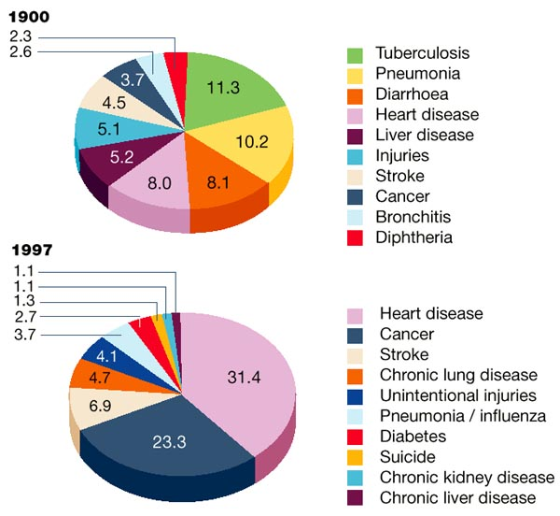
How has lifestyle changed the causes of disease?
The infectious diseases that killed people in the 19th century no longer bother us, thanks to antibiotics and vaccinations, but there has been a big increase in diseases caused by lifestyle. In 1900 25% of deaths were caused by infectious diseases, by 1990 it was less than 1%
Smoking has been a particular focus for successive governments. It became very popular in the 1920s but it wasn’t until the 1950s that doctors noticed the link between smoking and lung cancer.
It is associated with high blood pressure, cancers, heart disease and even gum disease and mouth decay.
Diet had also been a focus over recent years with the recognition that diet has a large impact on your health. Sugar and Fat are something that are eaten in excess today and can lead to diabetes and heart disease; lack of fruit and vegetables can also lead to health problems
Drinking too much alcohol can lead to kidney and liver problems; either though binge drinking or drinking too much over a long period
Unprotected sex and sharing needles has led to the spread of diseases such as HIV, which was only identified in the 1980s
Tanning has also led to an increase in skin cancer worldwide.
How has diagnosis improved?
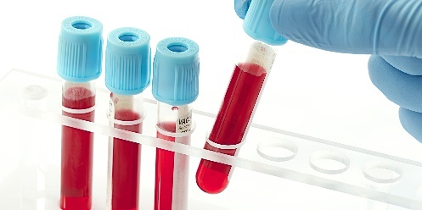  Blood Tests  Blood groups were discovered in 1901. This meant that doctors could now explain why some transfusions were successful and some failed. In WW1 a way to store the blood was discovered; which meant that blood could now be stored for future use. In the 1930s blood tests were developed that could test for illnesses without the patient having painful procedures | Blood Sugar Monitoring  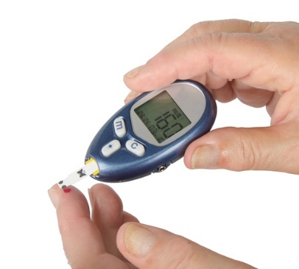  From the 1960s people who suffer from diabetes could check their blood sugar regularly and manage their condition.
X-Rays  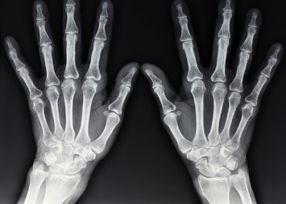  X-rays were discovered in the 1890s and it was realised that doctors could now view inside the human body without cutting it open. They are used most often to deal with broken bones | 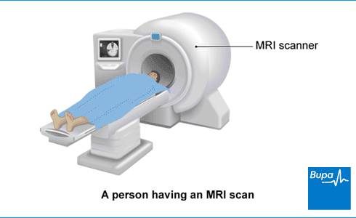  MRI Scans  MRIs were developed in the 1970s and use magnet and radio waves to diagnose soft tissue injuries.
Blood Pressure Monitors  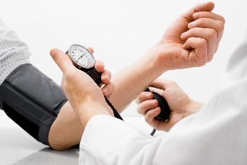  These were developed in the 1880s and help diagnose high and low blood pressure and related health conditions. | Endoscopes  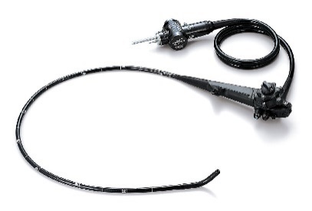  these have a camera on the end of a tube and can see inside the human body. They are usually used to investigate abdominal problems but can slo be used during surgery.
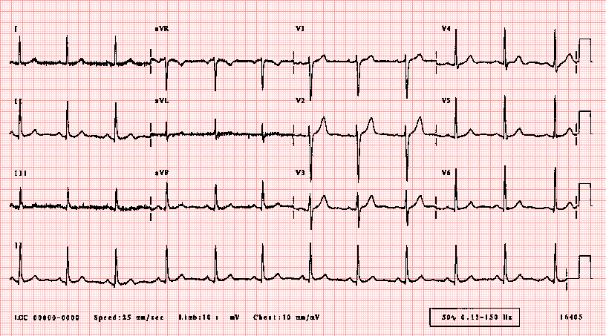  ECGs  (Electro cardiograms) use electrical pulses to check heart beats | CT Scans  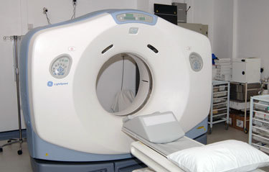  a more advanced form of X-rays and can be used to diagnose tumours and growths
Ultrasound Scans
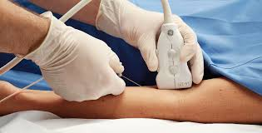
Use soundwaves to build up a picture. They can be used in pregnancy or to diagnose kidney or balder stones.

Explain one way in which understanding of the causes of disease and illness was different in c1750 to the present day 4 marks

Medical Treatments
Antibiotics are substances that kill bacteria or stop their growth. They do not work against viruses: it is difficult to develop drugs that kill viruses without also damaging the body’s tissues.
Magic Bullets
- A ‘magic bullet’ was a chemical cure that would attack the microbes in the body leaving the rest of the body unharmed. It was designed to target specific diseases. Paul Ehrlich (Germany: 1890s) reasoned that, if certain dyes could stain bacteria, perhaps certain chemicals could kill them. He set up a private laboratory and a team of scientists. By 1914 they had discovered several 'magic bullets' - compounds that would have a specific attraction to disease-causing microorganisms in the body, and that would target and kill them. The most significant was Salvarsan 606(for syphilis).

- In 1932 scientist Gerard Domagk discovered a bright red dye called Prontosil, killed bacterial infections. One day his daughter chased her guinea pig into his lab and in doing so cut herself, developing blood poisoning. Domagk was forced to try the untested drug on his daughter – it worked! It was the used to cut maternity deaths at a hospital in London and reduced them from 20% to less than 5%.

- It was discovered the Protosil prevented the bacteria from multiplying and made it possible for the body’s own immune system to kill the bacteria.

- Scientists began to look for other drugs that worked in the same way. The first true antibiotic was penicillin, other drugs continued to be developed throughout the 20th century such as Strepomycin (1943). In the short term they have been very effective and saved countless lives but in the long term bacterial strains can develop resistance to antibiotics. MRSA is very dangerous because it is resistant to most antibiotics. It is important to avoid over-use of antibiotics, so we can slow down, or stop, the development of other strains of resistant bacteria.

- It now takes a long time for drugs to be available as they have to be trialled; this is important though as mistakes were made in the past. Most notably with Thalidomide, which was prescribed to pregnant women in the 1960s and caused many birth defects.

Case Study: The Development of penicillin

How did Fleming discover Penicillin?

One of the most important medical advances in history began by accident. On the morning of September 3rd, 1928, Professor Alexander Fleming was having a clear up of his cluttered laboratory. He was sorting through a number of glass plates that had previously been coated with staphyloccus bacteria as part of research Fleming was doing.
One of the plates had mould on it. The mould was in the shape of a ring and the area around the ring seemed to be free of the bacteria staphyloccus. The mould was penicillium bacteria. He was not the first to do this – people in the Middle Ages understood the mouldy bread had healing properties and Joseph Lister had used it in 1871. Fleming had a lifelong interest in ways of killing off bacteria and he concluded that the bacteria on the plate around the ring had been killed off by some substance that had come from the mould. He wrote about his findings in a journal but did not believe that it could kill bacteria in living people – he could not find a way to extract a pure form of the bacteria which was needed for human testing, so he did not pursue it further.
What happened next?
Howard Florey was born in 1898 in Adelaide, Australia. He trained as a doctor and worked on a series of important discoveries at Oxford University. Ernst Chain a brilliant Jewish biochemist joined Florey's research team after he fled to Britain from Nazi Germany. Florey and Chain decided to develop Fleming's discovery further and set about finding a way to turn the penicillin mould juice into a pure drug, which would be more suitable for the treatment of humans. Their development of penicillin in the early 1940s led to the award of the Nobel Prize alongside Fleming in 1945.
Chain was researching penicillin in 1929 when he read Fleming's article. It was this research which encouraged Florey and Chain to set up a fuller investigation into the drug. In 1940, Florey's team found a way of purifying penicillin which was tested first on mice and then on a patient, a policeman called Albert Alexander. The patient began to recover after receiving the drug, but unfortunately supplies ran out due to their inability to produce it in large quantities. Mass production of the drug was not possible without the help of large drugs companies.
Florey managed to persuade US drug companies to mass produce penicillin when the US entered the war in December 1941 because it could be used to treat infections caused by war wounds. The US government gave grants to drug companies who wanted to buy the expensive equipment needed to make penicillin. Mass production began in 1943 by British firms. By 1944 there was enough penicillin being produced to supply all the Allied armies. The price of penicillin fell and soon it was being used throughout the world to treat a range of different diseases.

Why could they mass produce penicillin? | Government  The US government invested a huge amount of money to fund research into Penicillin; this is something that they could not have got in Britain
Individuals  Florey and Chain built on Fleming’s work and all three were dedicated to finding a chemical treatment for illness. Florey refused to patent the drug (have a government license) saying it should be available for everybody. This meant it could be manufactured very cheaply. | Technology  There were new ways to extract and mass produce penicillin; now the drug could also be stored which meant it could be made available in huge quantities
Science  Scientists were able to observe the bacteria and modify it to attack other types of bacteria. | Attitudes in Society  Fleming had worked as a doctor in the First World War and had seen how many soldiers had died as the result of a simple infection. By the Second World War an effective drug became more important and it meant that the clinical trials and evidence needed was cut so that it could be developed faster.

How was it used?
- It can be used to treat infection and also to prevent it e.g. tooth extractions
- The development of penicillin also allowed other doctors to look for other moulds that could fight bacterial infections. Dorothy Hodgkin mapped the chemical structure of penicillin in 1945, allowing other scientists to modify it to treat specific diseases.
- Confidence in doctors rose as a result
- BUT penicillin resistant bacteria first appeared in 1942 and this remains a problem in the 21st century.

The National Health Service 1948

The NHS officially began on July 5th 1948.
The National Health Service (NHS) is a nationalised healthcare system in the United Kingdom. It comprises of free at the point of access medical care in Hospitals, Accident and Emergency units, via General Practitioners (GP's) and via health visitors. It is designed to provide quality healthcare for all. Patients do not pay for emergency treatments, medical advice, periods in hospital or medical tests. originally patients were also entitled to free medication and free dentistry. This has since been amended and low, fixed fees apply for most patients for their prescriptions and Dental treatment.
Why was the National Health Service introduced?
Before the war there were many different kinds of healthcare providers in the country. Access to medical care, even in emergencies, varied in terms of availability and quality across the country. The problems that this created were made very apparent by the onset of war and this added strength to arguments for nationalisation (government run) of the health services in the United Kingdom.
What opposition was there to the NHS?
Until shortly before the official launch of the NHS a majority of doctors were opposed to the idea. Aneurin Bevan, the Minister in charge of introducing the NHS, had to work very hard to make sure that doctors were happy with the arrangements. In particular, there were concerns about workload, how it would work and that doctors would now be receiving a fixed salary.
What was the impact?
The NHS has had problems with having enough staff, enough beds and being able to fund drug treatments
In the short term, hospitals were not changed much since the 1900s and doctors were unable to keep up to date with medical developments. Combined with more people visited GPs, this created longer waiting times and less time to spend with each patient. Access had improved but provision did not improve until the 1960s.

What treatments are available in hospitals today?
The problems of pain, surgery and blood loss have all been solved so doctors can carry out more complex operations; new machinery also always people to have replacement organs and even limbs. A few examples are:
- Advanced X-rays (radiotherapy)
- Dialysis
- Heart bypasses
- Prosthetic limbs
- Organ transplants
- Laparoscopic (keyhole surgery)- being able to operate through tiny incisions
- Robotic surgery

Problems with developing treatments
- It is difficult to develop vaccines against viruses such as flu – this is why people are given a new vaccination each year to deal with new strains
- New diseases appear that do not respond to any chemical treatments
- Lifestyle factors have caused increases in illnesses such as heart disease and cancer
- Microbes are becoming drug resistant – such as MRSA. Even diseases like TB, where treatments were discovered in the 1960s, are on the rise again as the bacteria becomes drug resistant
- The NHS was just for treating sick patients, whereas before hospitals had been a place for rest and many elderly people lived out their last days there– this led to a gap in services.

‘Treatment of diseases and care of the sick completely changed after c1800’
How far do you agree with this statement?
You may use the following in your answer
- Magic bullets
- The NHS
You must also use information of your own 16 marks

Focus on the word ‘completely’ – the question is asking you about continuity and change. Nobody would argue things were the same in c180 so your answer should focus on whether it is entirely different or whether there are some things that are the same as previous centuries

Preventing disease in the 20th century
Since the beginning of the 20th century, the government has taken significant action to improve the public’s health. Why?
- We understand the causes of diseases so the government recognise that they can change things
- With an understanding of the causes, methods of prevention could be introduced:
Compulsory vaccinations
- 1942 Diphtheria: In 1942 3,000 children a year died of diphtheria; this co-ordinated the vaccinations so it was widespread.
- 1950 Polio and whooping cough: in the early 1950s there were around 8,000 cases a year in Britain. It causes paralysis; once the vaccination was introduced it decreased rapidly and the last UK case was 1984.
- 1961 Tetanus
- 1968 Measles
- 1970 Rubella (German measles): particularly dangerous for pregnant women

Government legislation
The government has passed laws to make the environment healthy e.g. the Clean Air Acts that aimed to clear London of Smog (heavy fog caused by air pollution). This is no longer a problem today but these laws continue e.g. limiting car emissions

In 2007 the government made it illegal to smoke in enclosed workplaces.

Communicating health risks
The government had helped to identify and tackle health risks e.g. during the Ebola outbreak in 2014-15 travellers to and from affected areas were tracked and quarantined where necessary. Warnings have also been put out those travelling to areas affected by the Zika virus in 2016.

Lifestyle Campaigns
The government has also been trying to promote healthy lifestyle through:
- Advertising the dangers of smoking, binge drinking, drug use and unprotected sex
- Events such as Stoptober which encourage people to stop smoking
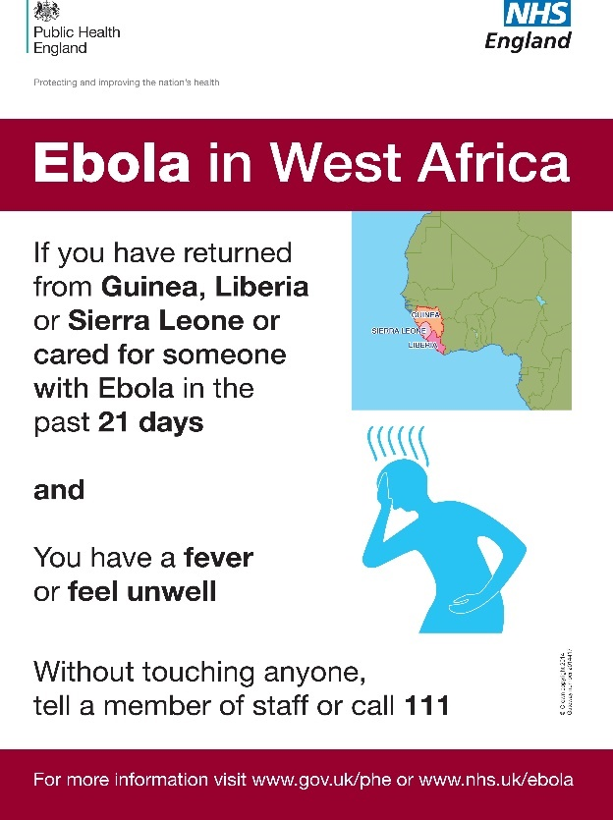
- Getting people to eat more healthily
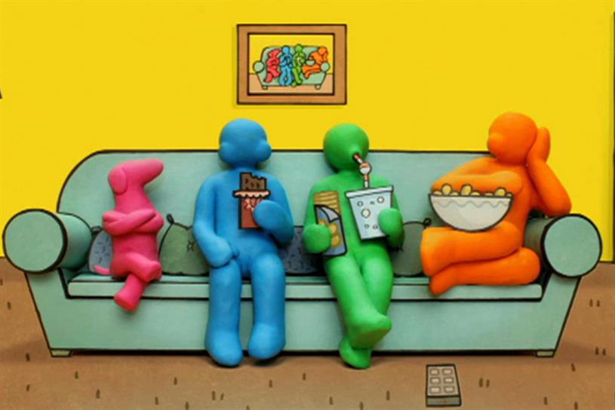

Explain why there was rapid progress in disease prevention after c1900
You may use the following in your answer
- Government interventions
- Vaccinations
You must also use information of your own 12 marks

Remember to use connectives to explain- don’t just describe what was done to prevent disease

Case Study: Lung Cancer in the 20th century
- Today Lung Cancer in the second most common form of Cancer
- Over 40,000 people are diagnosed with it each year
- Medical evidence has proved conclusively that cigarette smoking is the major reason for contracting Lung Cancer
- 90% of cases are due to smoking or passive smoking
- It is deadly because it is difficult to diagnose in the early stages. It is usually only diagnosed once symptoms develop which means the cancer might have spread. One 1/3 live for a year after diagnosis; only 10% live for more than five years.
- Other Cancer survival rates show more than 50% live for at least ten years after diagnosis.
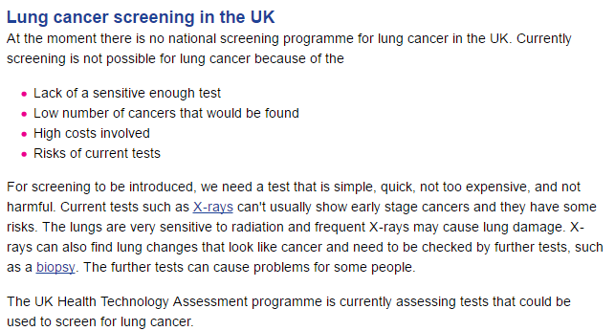

Treatments
- Surgery has been used since the 1930s but since many lung cancer sufferers have had other smoking related problems, surgery was too dangerous to use. New surgical techniques have included remote-controlled micro-instruments and cameras which have less impact and a faster recovery. It is also possible to transplant healthy lungs; however, this raises ethical questions about who should benefit from donated organs
- Radiotherapy aims to kill cancer cells using beams of radiation. Techniques have improved to target cancers more precisely.
- Chemotherapy has been used since the 1970s if surgery and radiotherapy is not successful. It involves using a powerful chemical to attack the cancer cells but has significant side effects. New combinations of medicines are constantly being used.
- Immunotherapy: Cancers are able to resist the body’s immune system’s attempts to block their growth. Trials have been taking place to boost the immune system and so stop the cancer cells from resisting it
- Genetic research: it is not possible to treat lung cancer using genetics but studying the genes helps doctors to work out appropriate treatments in those cases where there is a genetic mutation.
Preventions
Huge efforts are now made in prevention, diagnosis and treatment. Governments have launched major campaigns to prevent people developing lung cancer either to force people to change their behaviour or to modify it:
Changing behaviour – passing laws | Influencing behaviour – controlling communicating
in 2007 smoking was banned in the workplace including restaurants, pubs and cafes | Cigarette advertising on television was banned in 1965. In 2005 cigarette advertising was banned entirely including sponsorship of major sporting events
In 2007 the legal age of buying tobacco was raised from 16 to 18 to reduce the number of teenagers who smoked. | There have been campaigns to advertise the dangers of smoking. This has been on the TV, on cigarette packages and in schools
In 2015 a law was introduced that banned smoking in cars carrying children under the age of 18 | All cigarette products in shops have now been removed from display
Increased taxation on tobacco products has been introduced

Cholera vs. Lung Cancer
Limited short term impact= – John Snow presented his findings in 1855 but it took about twenty years for action to be taken (even this was not directly related to his findings) | Limited short term impact –  Lung cancer was linked to smoking back in the 1950s but the government did not intervene until the 1980s when death rates became very high
Bigger long term impact– 1875 Public Health Act was introduced after the Germ Theory proved that Snow was right | Bigger long term impact – government has tried to force and influence people’s behaviour such as smoking bans and rules on advertising.

